Title of the research work
Second line of the title or tag line
Name of Author One∗, Dept and affiliating institute/university name
Name of Author Two†, Dept and affiliating institute/university name
Name of Author Three‡, Dept and affiliating institute/university name
Name of Author Four§, Dept and affiliating institute/university name
Email: ∗author.one@add.on.net, †author.two@add.on.net, ‡author.three@add.on.net, §author.four@add.on.net
Abstract— This document is a template for preparing manuscripts for JIENT. This paragraph demonstrates multi-paragraph abstract formatting. The abstract should be of 150-200 words.
Index Terms— 4-5 keywords separated by comma (Ex: AI, Embedded Systems, IoT, VLSI)

INTRODUCTION
The introduction provides background information and defines the research problem. This paragraph elaborates on objectives and contributions.

Subsection: Reference Citation Example
Example of reference citation: This method is widely used in embedded systems [1].
- Subsubsection Example:
Write the subsubsection text here.

- METHODOLOGY
Here you describe how the study was conducted. It includes the design, materials, tools, algorithms, datasets, and procedures used, so others can understand or replicate the work.
paragraph change: Here you describe how the study was conducted. It includes the design, materials, tools, algorithms, datasets, and procedures used, so others can understand or replicate the work.
- Double-Column Figure
An example of a floating figure using the graphics package showing Figure 1.
__________________________________________
Manuscript received January xx, xxxx; revised January xx, xxxx, published January xx, xxxx
Corresponding Author Email: email@example.com
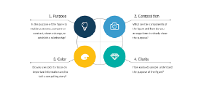
Fig. 1. Caption of figure 1.
- Single -Column Figure
An example of a floating double-column figure using subfloats showing Subfigures 2a and 2b in Figure 2.
- Equation
An example of a writing an equation is as below:
$E=mc^{2}$ (1)
- Floating Table
This is an example of an JIENT floating table showing Table I.
Table I
EXAMPLE OF A TABLE
Header | Header | Header
One | Two | Value
One | Two | Value
One | Two | Value

This is an example of a merged row table II.

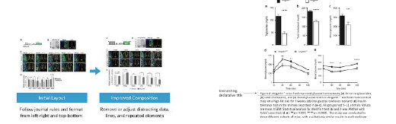
(a) Case 1 (b) Case 2
Fig. 2. Single column figure.
Table II
EXAMPLE OF ROW MERGED TABLE
Header | Header | Header
One | Two | Value
One | Three | Value
Two | Four | Value
Two | Five | Value

This is an example of a merged column table III.
Table III
EXAMPLE OF COLUMN MERGED TABLE
Header | Column 1 & 2 merged
One | One
Two | Two
Three | Three
Four | Four

- RESULTS
This section presents the findings of the study without interpretation. It includes data, observations, tables, graphs, or performance metrics obtained from experiments or analysis.
- DISCUSSION
The discussion interprets the results. It explains their significance, compares them with existing work, highlights implications, and may mention limitations and future scope.
- CONCLUSION
This section summarizes the findings of this research work.
ACKNOWLEDGMENTS
The authors would like to thank the funding institute/ organization for the support.
REFERENCES
- A. Kumar and B. Singh, “Deep learning approaches for image classification,” Journal of Intelligent Systems, vol. 12, no. 3, pp. 45–56, 2023.
- S. Sharma, “IoT-based smart home automation system,” in Proceedings of the International Conference on Smart Technologies, 2022, pp. 101–105.
- T. Brown “Artificial Intelligence Trends Report,” OpenAI Research, White Paper, 2024.
- I. Goodfellow, Y. Bengio, and A. Courville, Deep Learning, MIT Press, 2016.

